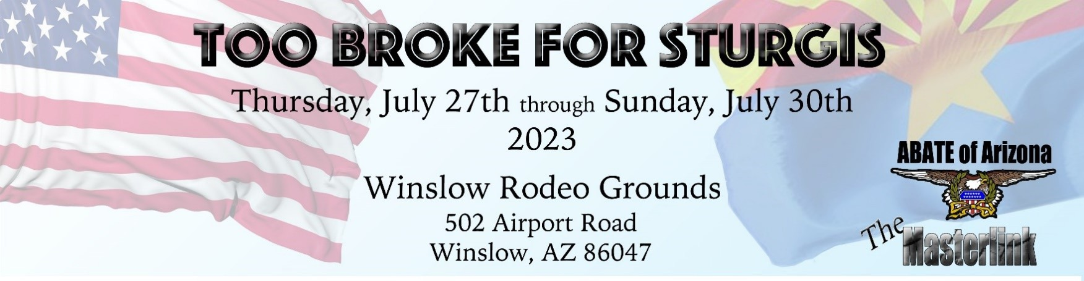

Too Broke For Sturgis – We’re Back!

It’s easy to dismiss this high-desert town of 9000 as you fly by doing a buck on I-40. Easy, but a mistake. Talk to the people who call it home and you’ll hear pride and excitement about what’s going on there today. You’ll also hear some cool stories about the town’s history.

“Winslow? In July? Too hot, nothing going on there.” – non-Bikers

“Winslow? In July? Too Broke For Sturgis? Hell yeah!” – Bikers from anywhere

The 12-plus square miles we call Winslow today was home to the Homol’ovi people 1,600 years before it was selected as the townsite for the Atlantic and Pacific Railroad’s transcontinental line in 1880. The Little Colorado River was a critical water source for the ancients, the more contemporary Hopi and Navajo tribes, wagon trains crossing the fledgling USA, including Mormon settlers from Utah, and finally for the railroad expansion that made Winslow a boomtown. This rich mix of cultures continues to make Winslow a vibrant community.

Named for railroad official Edward F. Winslow, what had been a water-source crossroads became a major rail city connecting the two coasts, supporting the shipping of livestock, lumber and many other trade goods. In the 1920s, Route 66, aka The Mother Road, started a nearly 60-year tradition of 2- and 4-wheel tourism right through the middle of the town; at the height of the route’s popularity, thousands would ride and drive through in a single day.
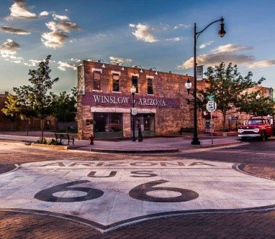
Charles Lindbergh also recognized Winslow as a major point on the map between east and west in the 1920s. Although the airport is no longer used for commercial traffic, it was part of aviation history when it was designated as a key fueling stop along Transcontinental Air Transport’s (TAT) first coast-to- coast passenger route.

Lindbergh was head of TAT’s Technical Committee at the time. According to the airport’s Wiki, it was the only all-weather airport between Albuquerque and Los Angeles for many years. During WWII, the US military used it as a refueling and repair shop and it is used currently as a firefighting air tanker base by the US Forest Service.
You can read more about the Winslow-Lindbergh Regional Airport here.
Page 1
It’s not like Chicago & the Blues, or New Orleans & Jazz, but Winslow has some interesting musical connections, the most notable from the 60s and 70s. This period was no exception when it came to the connection between the biker culture and music.

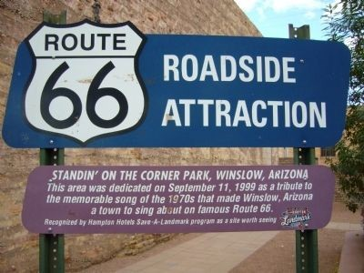
Many bikers today started their love affair with 2 wheels during that time, and will find Winslow’s Standin’ on the Corner a nostalgic must-visit spot. And their kids and grandkids who ride, or just appreciate the Biker community and who’ve heard the song as an Oldie, can relate to the song’s advice to just chill.

Another less known musical connection in Winslow involves the now-famous Jackson brothers. The Jackson 5 was just starting out in the 60s and they didn’t yet have national exposure. But they were working hard toward that goal, including spending a few summers with their grandfather on Snyder Avenue. The story goes that he cracked the whip if the boys didn’t stay focused on their music. If you want to read more about them, here’s an article from the regional Tribune.

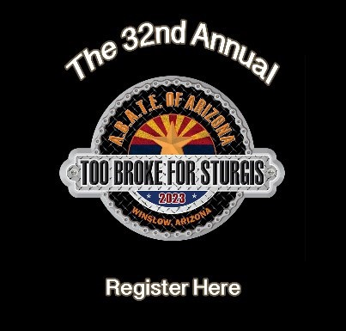
One other musical point of interest is that Natives who worked for the railroad formed The Santa Fe All-Indian Band in 1923 and went on to play many special events before they disbanded in 1964. One of their more high-profile performances was President Eisenhower’s 1953 inauguration parade in Washington DC.

You can find more out about these and many other unique historical and cultural topics at the Old Trails Museum. And for a very thorough “Things to Do” list and local history, check out this post by ArizonaJourney.org.

As a nearly life-time Arizonan, it was surprising to me how rich a history Winslow has that I was totally unaware of. There are many things to check out in and around Winslow – so much so that people might start calling the Sturgis ND Rally “Too Late for Winslow”.

Sandra ‘Jane’ Bell – Secretary, High Country Chapter

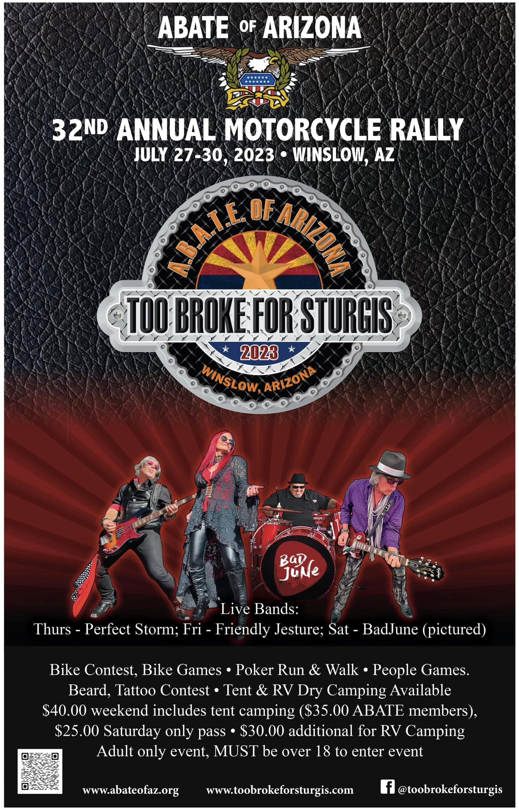

Page 2

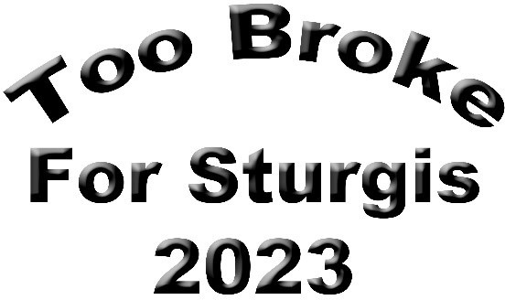
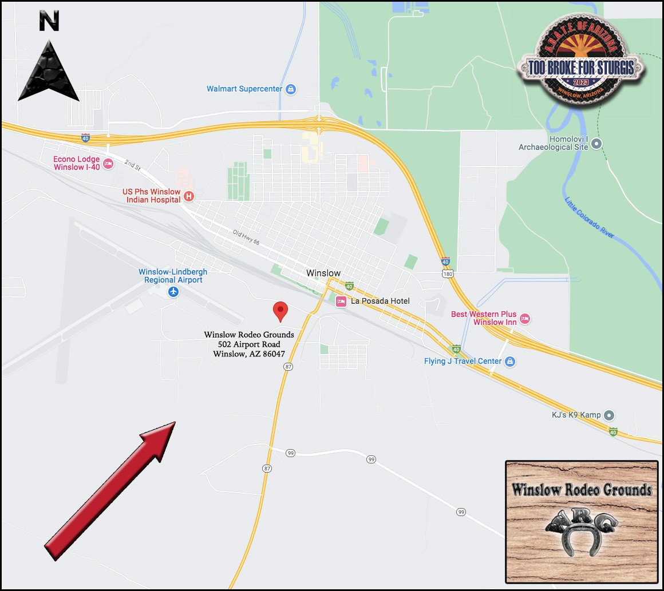

$40 Weekend Pass ($35 ABATE Members)*
$25 Saturday Only Pass*

*Entry includes tent camping
$30 Additional fee for RV camping
Page 3

12:00pm Registration Starts
Friday

Live music Perfect Storm
6:00pm - 10:00pm
Location: Main Stage

Registration Ends 8:00pm
9:00am Registration Starts Breakfast 7:00 - 9:00am (Free)
provided by Desert Oasis Ministries
Donations accepted Location: On grounds

50/50 & Raffle Items Located at the Merchandise booth. Buy tickets through the weekend at Merchandise booth or from the walking vendor selling them.

Poker Walk 11:00am - 3:00pm
Pick up Poker form at the Merchandise booth. Stop by 1 of 5 booths that have a number displayed for a card.
Turn your completed form in at the merchandise booth.

People games 1:00pm - 4:00pm Sign up on clip board in arena

Fantastic Moustache & Beard Contest
4:00pm - 5:15pm Sign up on clip board in arena Location: Main Stage
Sponsored by: Elks Lodge #536
Tattoo Contest 5:15pm - 6:00pm Sign up on clip board in arena Location: Main Stage

Acknowledgements & Announcements
6:00pm - 6:15pm Location: Main Stage

Live Music Friendly Jesture
7pm - 11pm Location: Main Stage

Registration Ends 8:00pm

9:00am Registration starts Breakfast 7:00am - 9:00am (Free)
provided by Desert Oasis Ministries
Donations accepted Location: On grounds

Live Music Perfect Storm
10:00am - 1:00pm
Location: Main Street Park (Town of Winslow)
Street will be blocked off for -Bikes only- (Photo shoots)

Bike Show Entry Registration 11:00am - 12:00pm Location: Arena Sign up on clip board in arena Voting 12:00pm - 1:00pm Sponsored by: GWR, LLC.

Awards, National Anthem,
Bike Blessing & Revv Up 1:30pm Location: Arena
Bike Games 2:30pm - 5:00pm Sign up and games at arena
Sponsored by: Dirty Dogg Saloon
Saturday

Acknowledgements & Announcements
5:30pm - 5:45pm Location: Main Stage

Wet T-shirt Contest
6:00pm Location: Main Stage Sign up on clip board in arena
Sponsored by: Blue Collar Customs

Live Music Bad June
7:00pm - 11:00pm
Location: Main Stage

50/50 & Raffle Drawing During band break Location: Main Stage
(Winner must be present to win)

Registration Ends 5:00pm

Breakfast 7:00am - 9:00am (Free) provided by Desert Oasis Ministries Donations accepted
Sunday
Worship Service Conducted by Christian Motorcyclists Association 8:00am Location: Main Stage

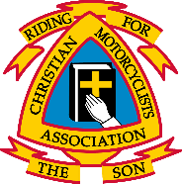
Saturday
Friday
Thursday

Page 4

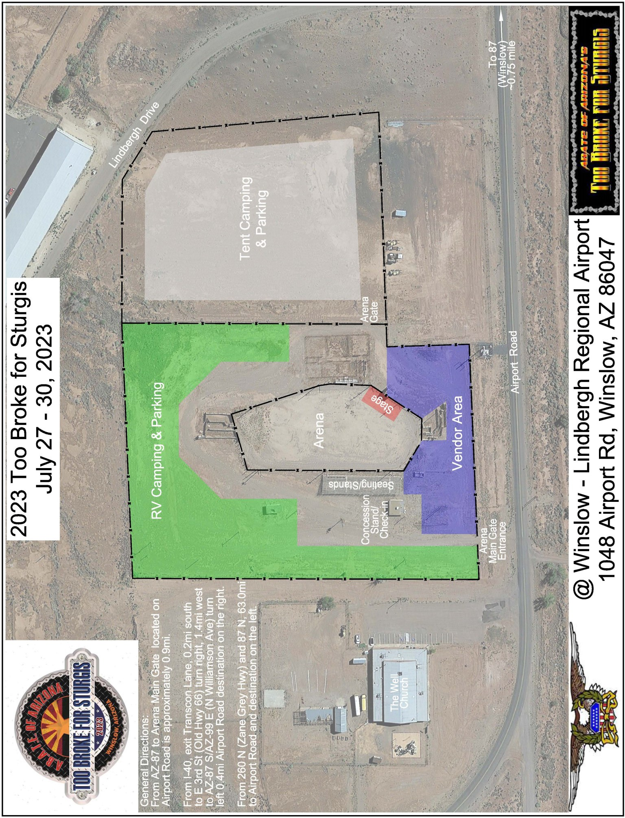

Page 5

